Developing Soft and Parallel Programming Skills Using Project- Based Learning

Spring 2019

Team Hacks

Vincent Hu, Jeffery Kong, Mohamed Ali, Sabina Maharjan, David Carr

Task 1: Planning and Scheduling

For assignment two, we chose a new coordinator: Jeff Kong. Jeff set up the team meeting and emailed Kexin the info about our group.

The assignments for assignment two were as follows:

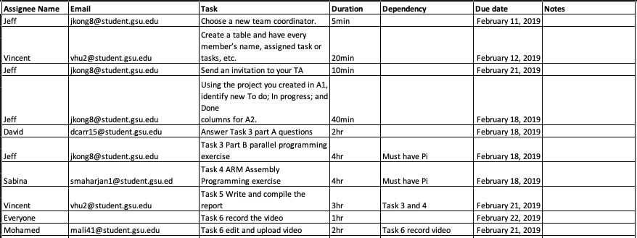

Task 2: Teamwork Basics

We invited Kexin an invitation to our team Slack. I only hope that he did not receive too many notifications because we are very active on our slack. We use it to discuss team projects but also to communicate about the class in general.

We created and assigned tasks in Github. Attached is a screenshot of the tasks we created for assignment two (in progress and done).

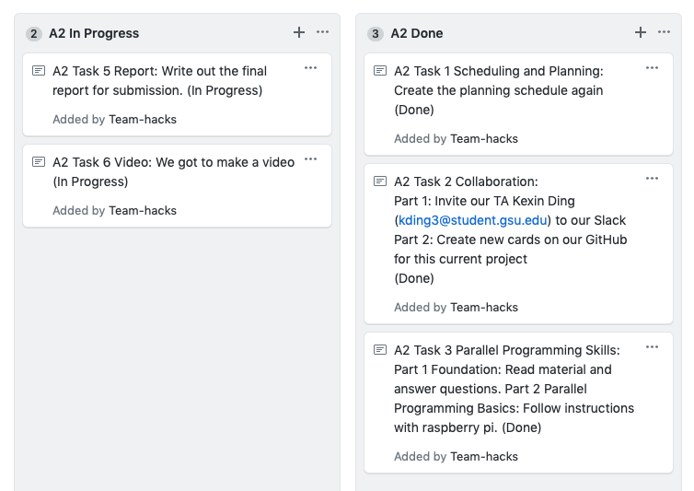

Task 3 part a) Parallel Programming Skills

1) (5p )Identifying the components on the raspberry PI B+

Single Board Compute, Multicore CPI, 1GB RAM (Random Access Memory), USB port, SD slot that contains the operating system, Ethernet connecter for a direct connection, HDMI cord to connect to TV or Computer screen, audio jack, and a power connector.

2) (5p) How many cores does the Raspberry Pi’s B+ CPU have

It is a multicore system; the Raspberry Pi B+ contains four which is why we call it a Quad-Core CPI.

3) (8p) List three main differences between X86 (CISC) and ARM Raspberry PI (RISC). Justify you answer and use your own words (do not copy and paste)

- Data can be stored differently between the two, when it comes to storing data ARM is more versatile reason being that it can switch from little to big endian, a storing architecture, and vice versa where as x86 strictly works with little-endian.

- Even though ARM may succeed in storing data, x86 comes with far more features that make the programmers life a lot easier. X86 allows the program to access the memory through multiple points where as in ARM you have to use registers and move the register to memory and you can’t do certain Instruction formats as in Memory to Memory which can in turn get a little bit confusing.

- Since ARM works on a RISC (Reduced Instruction set Computing) it allows the speed of the program to move much faster rather than x86 because of it having to go through its multiple instruction sets.

4) (6p) What is the difference between sequential and parallel computation and identify the practical significance of each?

Sequential is an older form of computation where each instruction was separated, and the instruction would be executed once at a time. Whereas parallel computation it takes advantage of the processor and does multiple instructions simultaneously and speeds up the runtime. Sequential computation operates only one process at a time. Instructions are executed one at a time.

5) (5p) Identify the basic form of data and task parallelism in computational problems.

Breaks the problem into different parts based upon the instruction set, then broken down into a list of instructions that are worked on at the same time and then runs through the processors. Generally, data parallelism processes the same task on different batches of data, while task parallelism breaks down the task into different parts that can be processes simultaneously.

6) (6p) Explain the differences between processes and threads.

Threads and processes run on different forms of memory, where a thread shares its memory space and a processor has its very own. Threads can be run in a processor but not the other way around.

7) (3p) What is OpenMP and what is OpenMP pragmas?

OpenMP (Open Multi-Processing) is an API used to help programmers and give them a basis instead of starting from scratch. OpenMp pragmas allow you to fork/join threads together where as some threads aren’t as versatile.

8) (4p) What applications benefit from multi-core (list four)?

Compilers (Winrar)

Multimedia applications (Photoshop)

Database servers (Google)

Anti-virus Software (Security Essentials)

9) (4p) Why Multicore? (why not single core, list four)

Multi core speeds up the runtime of programs, gives humans the ability to use multi-task on their CPU, from watching a YouTube video and downloading a game at the same time. Allows us to stretch the size of the memory because of more Busses. Able to distribute power better which stretches battery life for computers.

Task 3, part b) ARM Assembly Programming

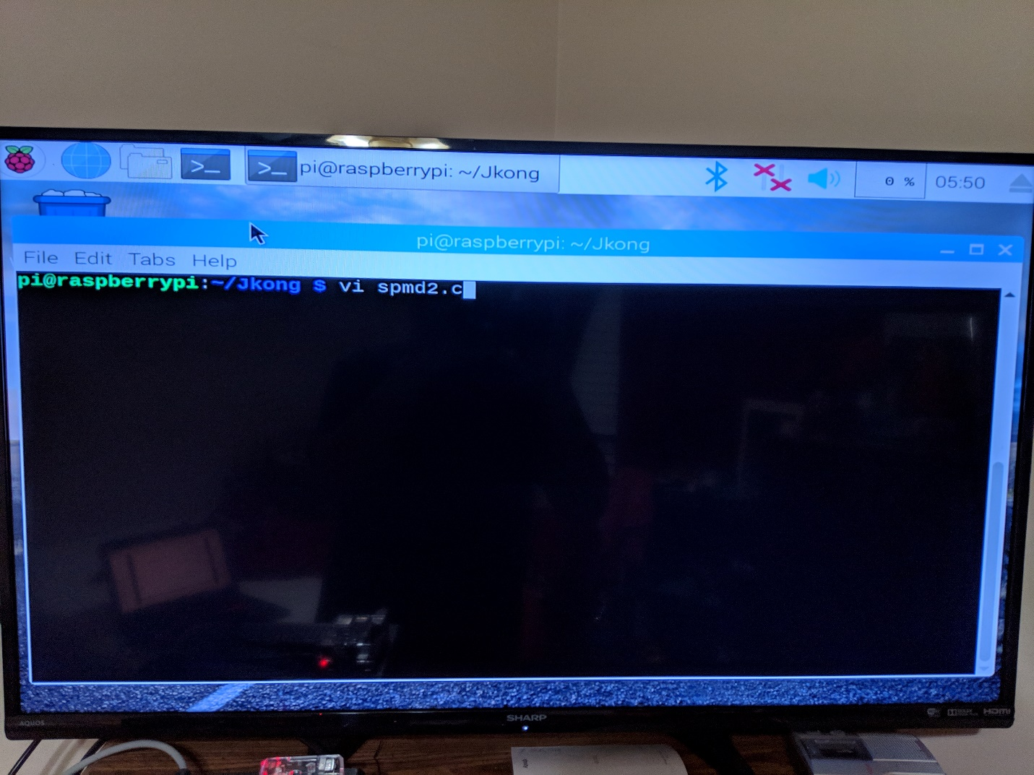

I have connected my Raspberry Pi to my monitor and booted it up. Having opened the terminal, I began by creating my own directory to organize the files inside the Raspberry Pi. The project task asks us to recreate spmd2.c file using the “nano” text editor however, I felt more comfortable using “vi” editor, so I used that instead.

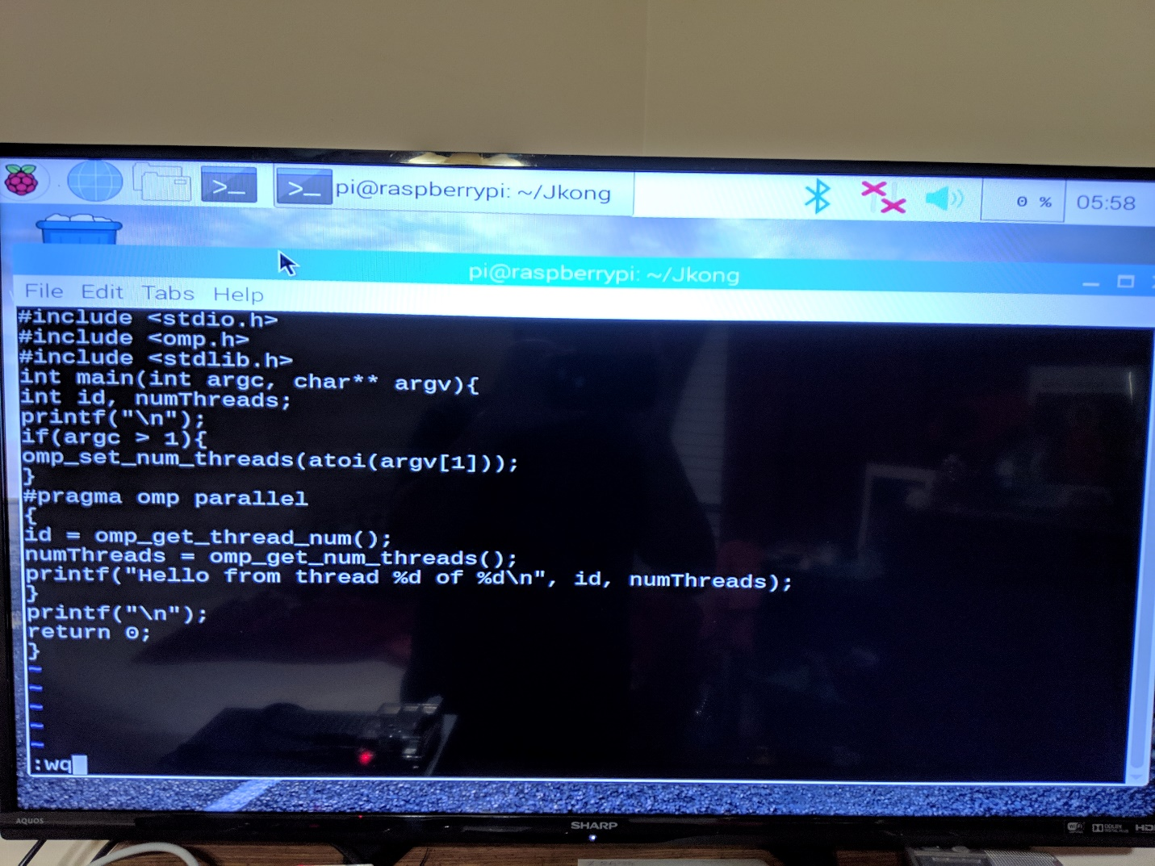

Here is my created spmd2.c file before I saved and quit the “vi” editor.

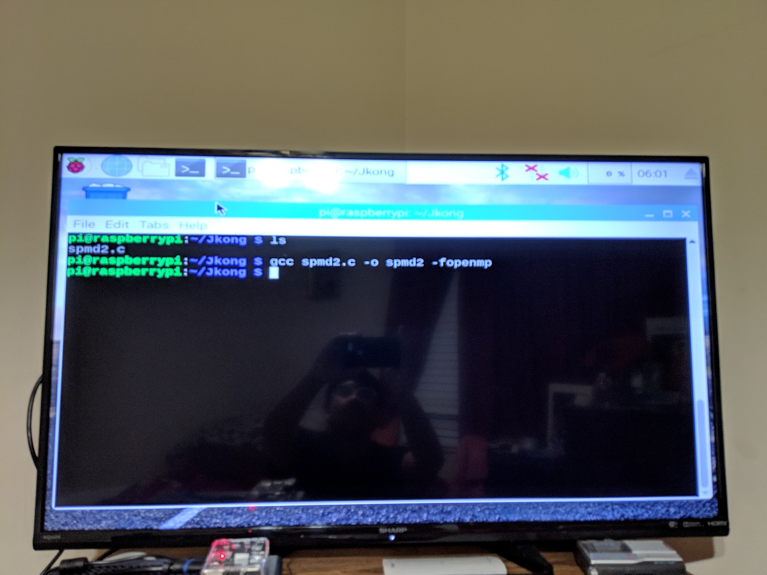

After quitting “vi”, I checked my directory to make sure the file is there. Then I compiled the file with the “gcc” command and used the “-o” option to rename the executable to “spmd2”. No errors were detected in the compiling of the spmd2.c file, so everything seemed good.

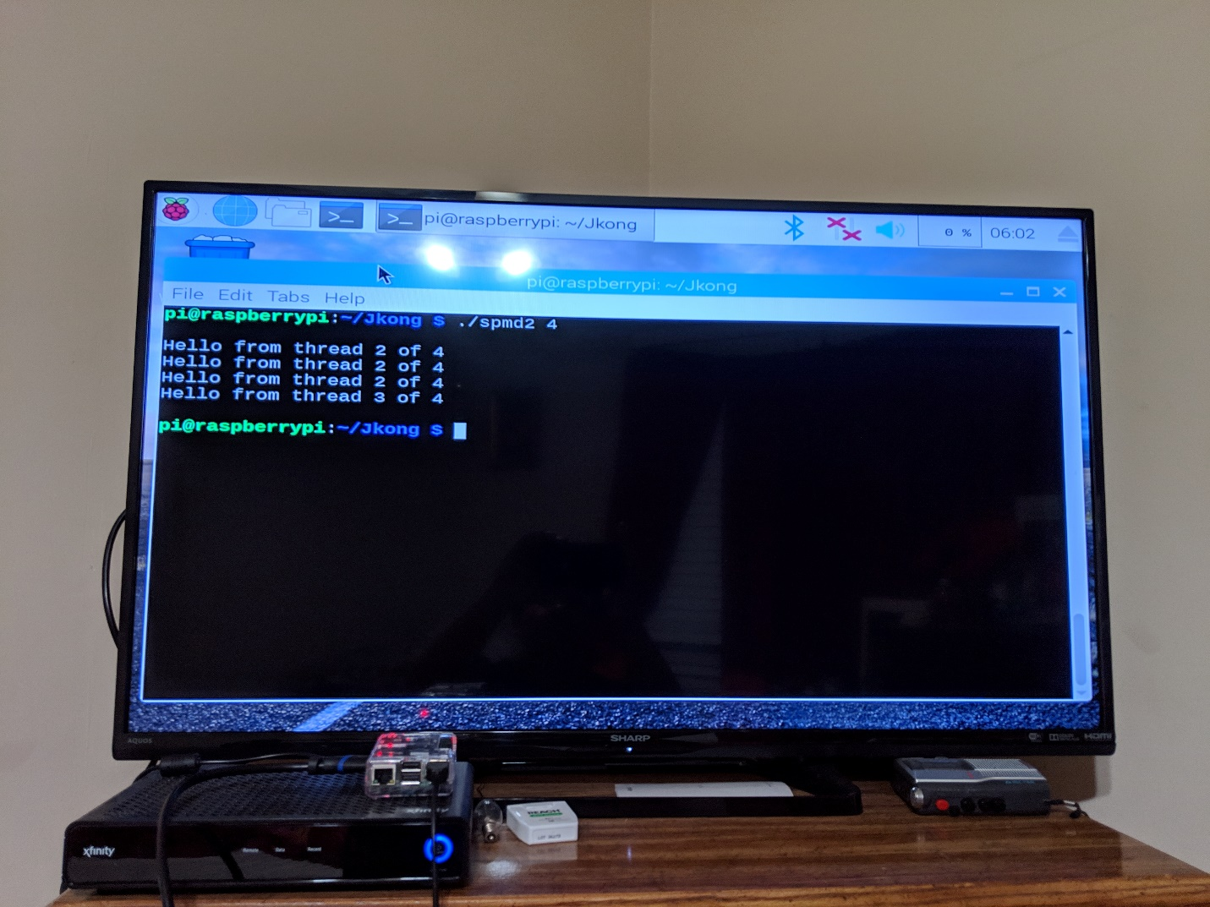

This is the output from running the spmd2 executable. At first, I was looking the output of each thread to be printed sequentially. For example: thread 1 will print then thread 2 will print and so on and so forth. But the programming task assured be that its normal since we couldn’t tell which thread will finish first. However, having the same thread id is not good. According to the programming task, improperly placing your variable declarations will cause your threads to share that variable’s memory space. So, I had to go fix it.

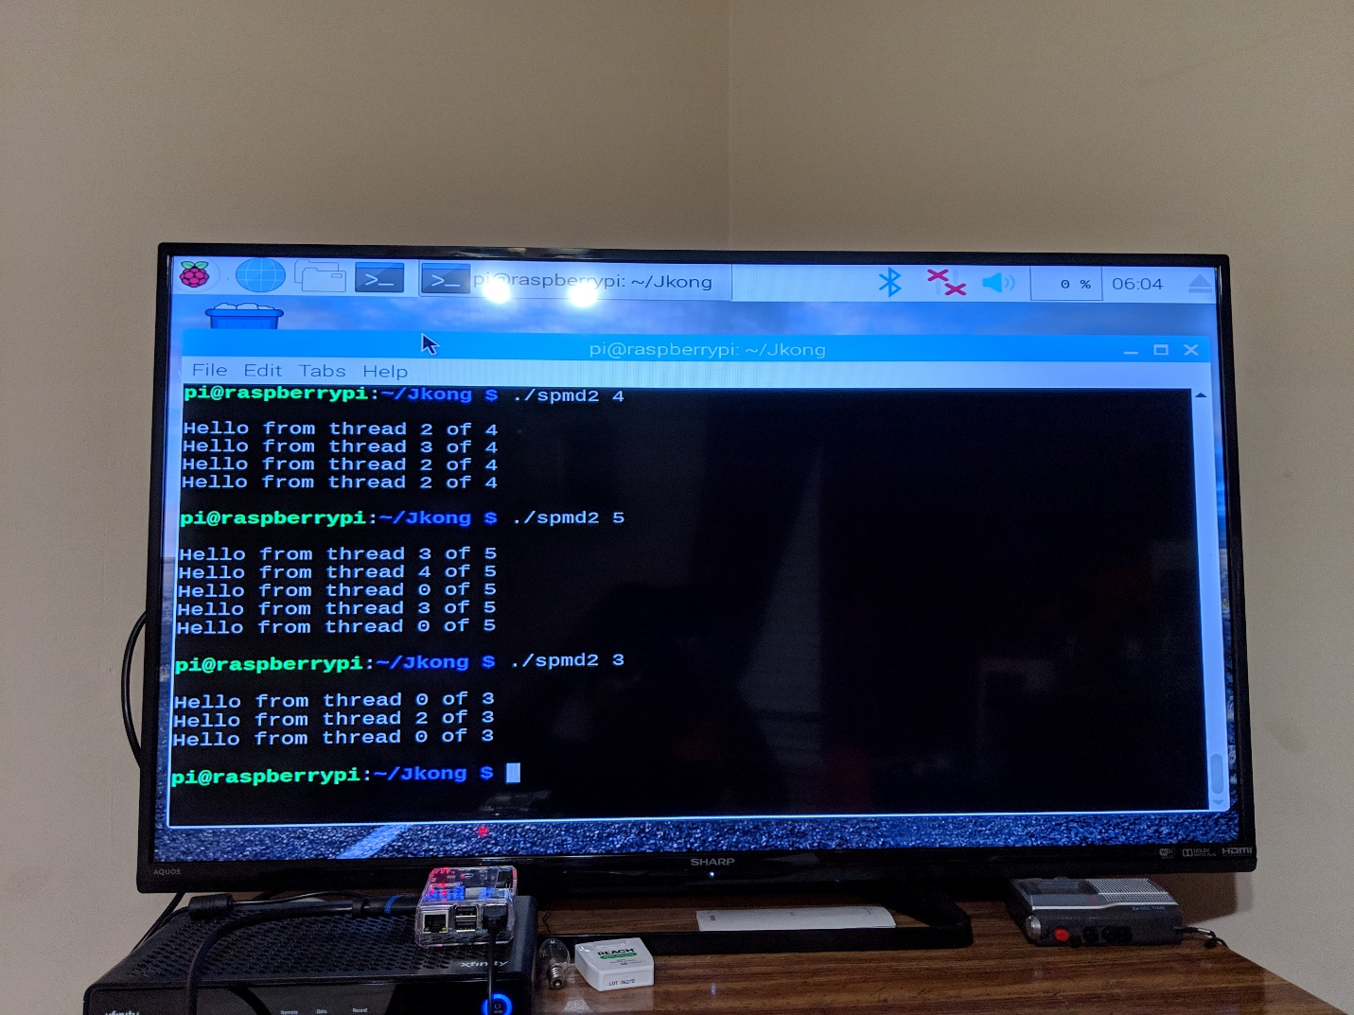

Here is me calling the smpd2 program with different number of threads before fixing it, just to see what would happen.

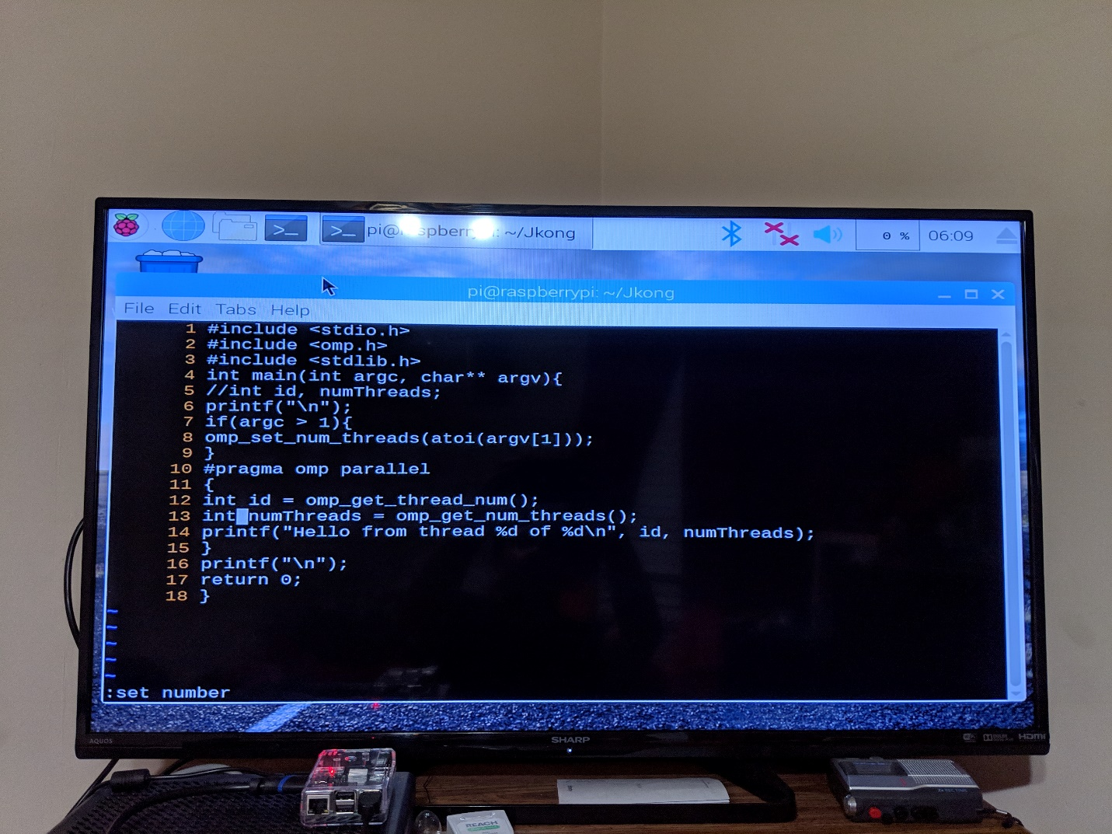

Back inside the “vi” editor, I commented out the initial declaration of “id” and “numThreads” that I wrote at the beginning of the programming assignment and initialized those variables inside the block of code that will be forked.

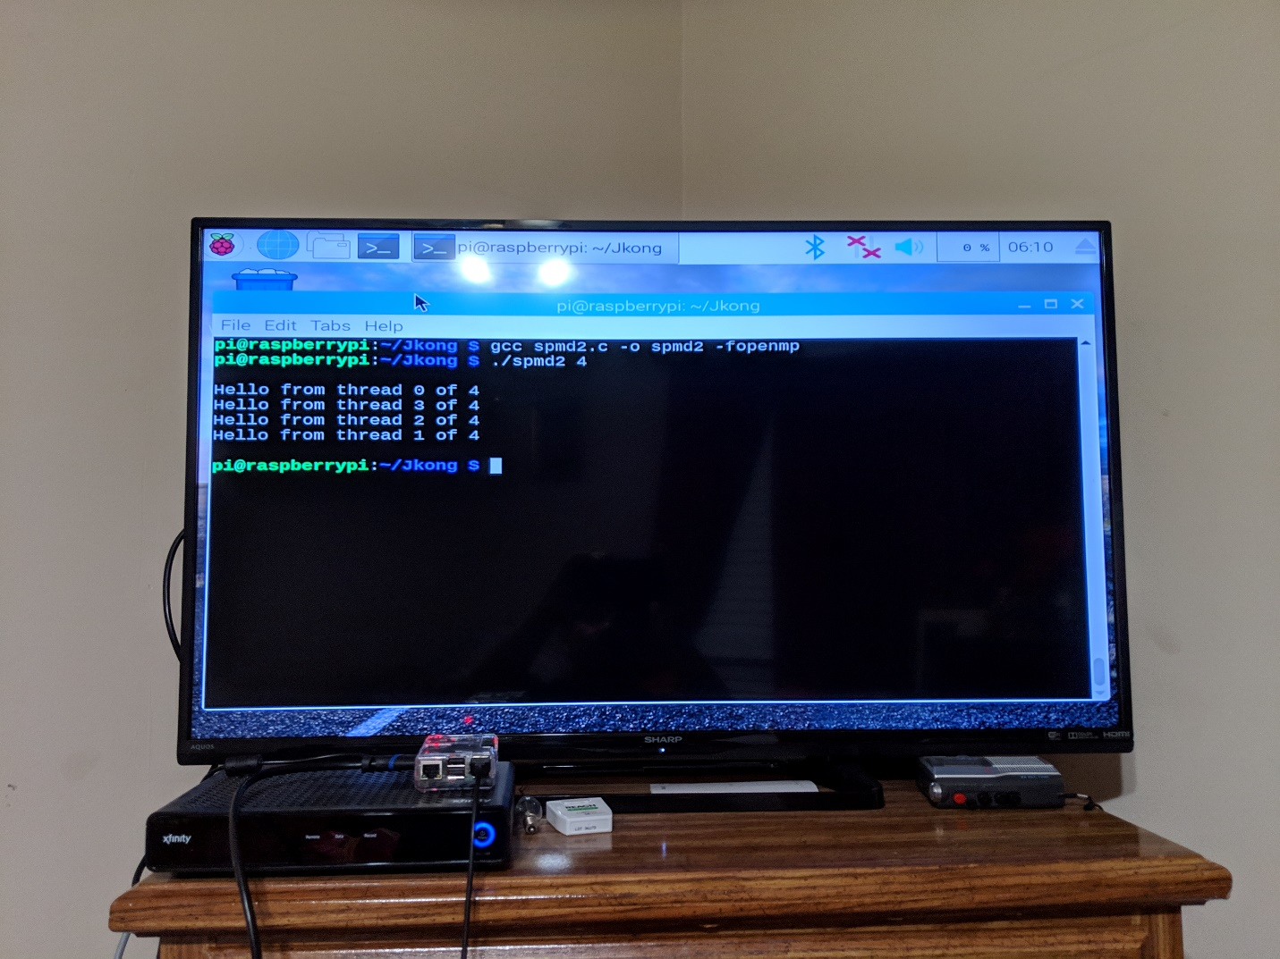

Here is me compiling the edited spmd2.c file and running it again. Each message has the proper thread id, which is what we wanted.

Task 4: ARM Assembly Programming

For the second program- arithmetic2.s, we followed the assembly code as the reference (and was supplied with the assignment instructions) was:

@ second program: c = a + b

.section .data

a: .word 2 @ 32-bit variable a in memory

b: .word 5 @32-bit variable b in memory

c: .word 0 @32-bit variable c in memory

.section.text

.globl _start

_start:

ldr r1, =a @ load the memory address of a into r1

ldr r1, [r1] @ load the value a into r1

ldr r2, =b @ load the memory address of b into r2

ldr r2, [r2] @ load the value b into r2

add r1, r1,r2 @ add r1 to r2 and store into r1

ldr r2, =c @ load the memory address of c into r2

str r1, [r2] @ store r1 into memory c

mov r7, #1 @ Program Termination: exit syscall

svc #0 @ Program Termination:wake kernel

.end

Step 1:

@ indicates line comment in the code.

.data section is meant to store the data for the assembly code

.text stores the actual code.

.global_start denoting to the assembler from where the actual code begin.

the assembly instructions mov, sub and add are self-explanatory and is also explained with the in-line comment in the code.

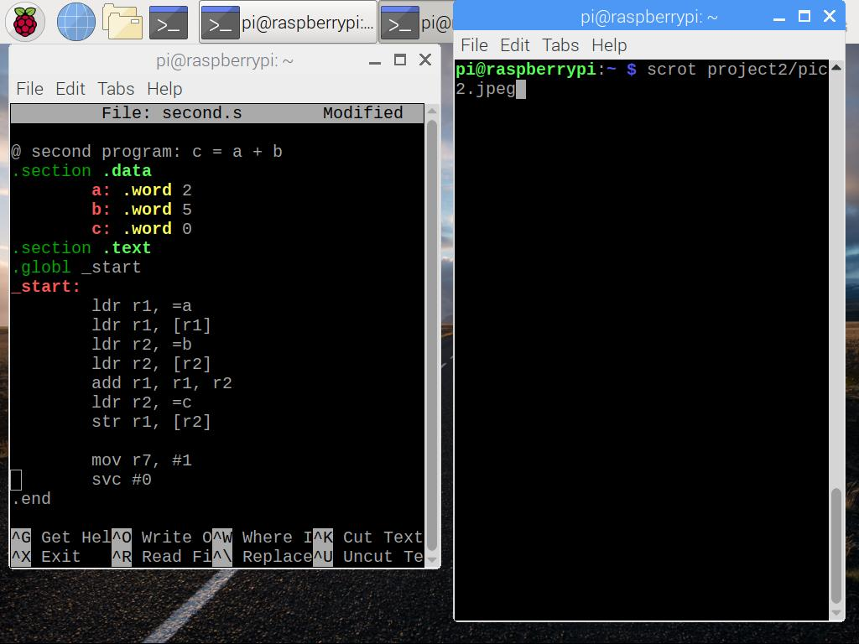

Step 2:

The program arithmetic2.s is build in the following way:

Firstly, val1, val2, val3, and val4 are defined in .data section.

Then the memory addres of val1, val2, val3, and val4 into r3, r1, r2, and r4 respectively are loaded with the values into a registers.

After that, immediate value 9 is added to r1 and then r2 to r1 which is stored to r1. later, r3 from r1 is subtracted and stored to r1.

Lastly, r1 is stored into memory val4.

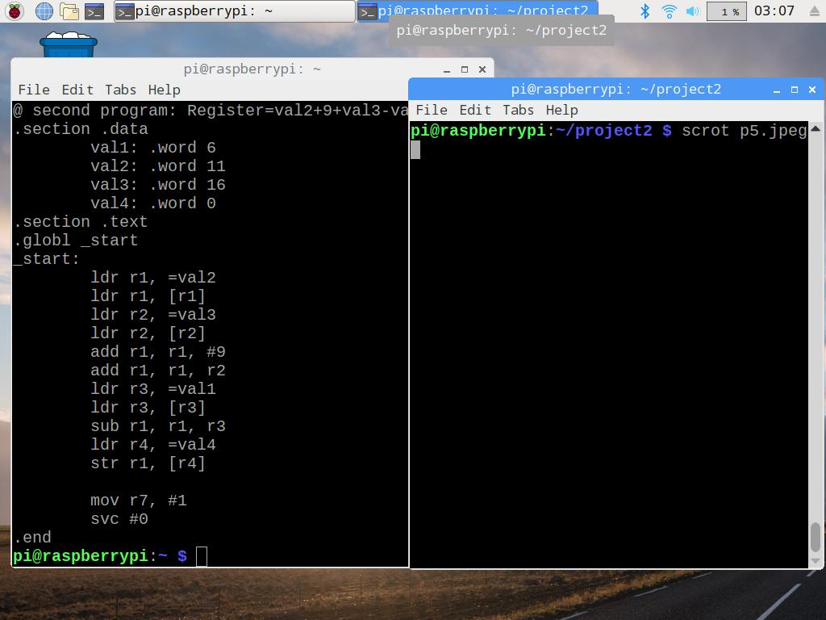

Step 3:

After assembling and loading the program, everything seemed to run smoothly.

Since running the program did not produce any output, GNU Debugger was used to make sure the code ran properly and allow us to see the visually what was happening at each step.

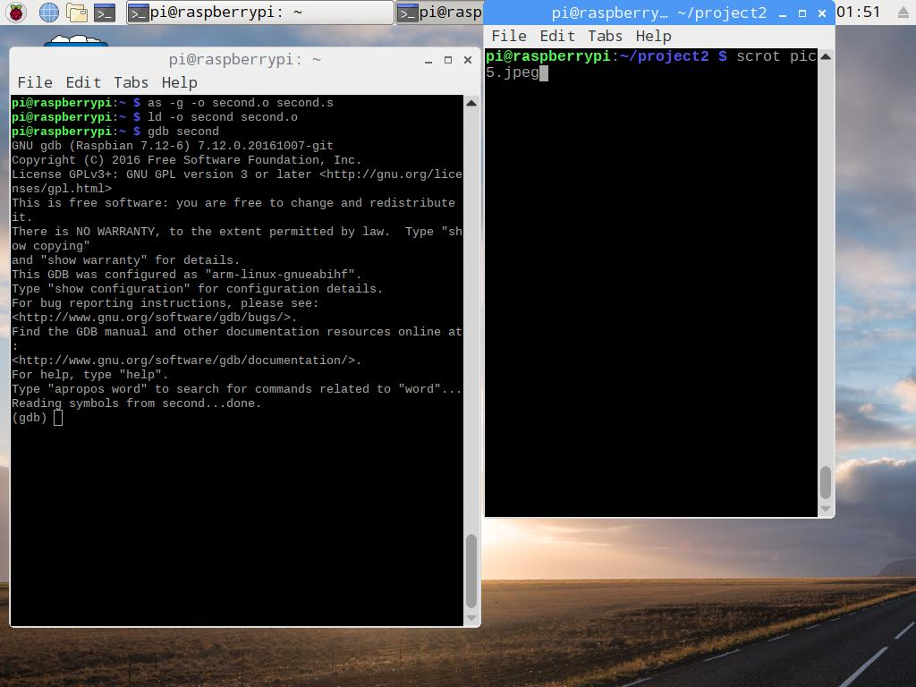

Step 4:

After running the code with gdb and setting the break point at line 20, the register values is as expected. r1 should have a value of 30, because 11+9+16-6 is 30. r2 and r3 were both set to val3 = 16 and val1 = 6 respectively. And because we stored the val4 into r4, it gave us memory address.

Lastly, we examine the memory got ‘0x0000001e’ as an answer. The decimal value in hexadecimal is 1e. To examine the memory ,we used the command:

(gdb) x/4xw 0x200c4

Where, 4 is the number of items (variable), x is the format (hexadecimal), w is the size (word), and 0x200c4 the memory address.

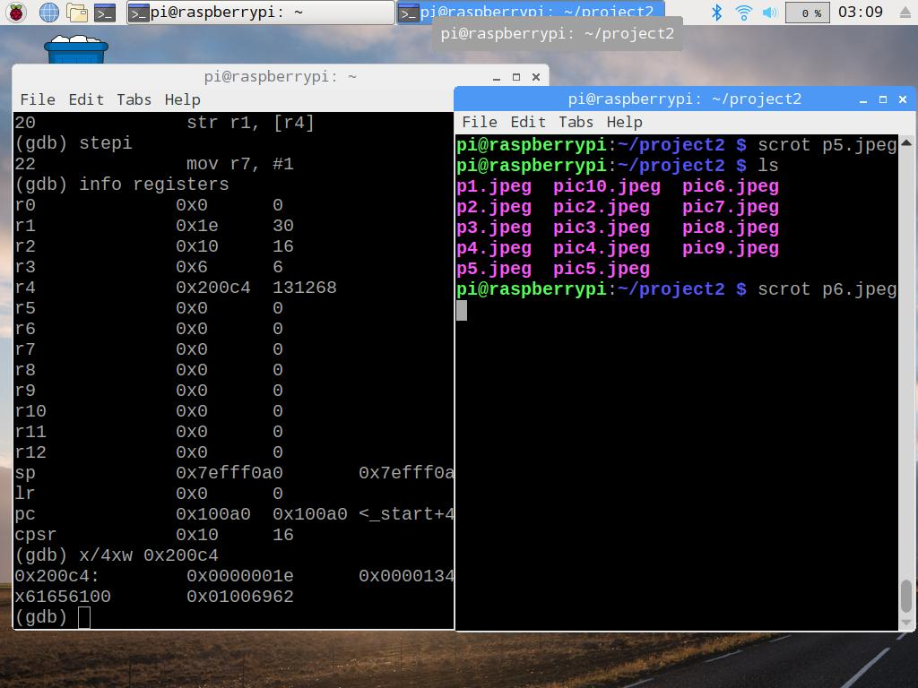

Appendix

Slack link: https://hacks-org.slack.com

Github Link: https://github.com/Team-hacks

Video Link: https://www.youtube.com/watch?v=bGzWjeU2B7M

Screenshots:

